Senior Cup

Competition Instructions.

1. Any club playing in a County or District Cup tie on the same date as this Competition
must advise the F.A. Secretary and League Secretary and opponents immediately.

2. Referee’s Fee - £35.00 plus 30p per mile travelling expenses.
Asst. Referees Fees- £20.00 plus 30p per mile travelling expenses.

3. Matches are 45 Minutes each way. If the result is a draw, the match shall be decided
upon by the taking of penalties, as laid down in the laws of the game.
NO EXTRA TIME WILL BE PLAYED.

4. The Home Team must confirm this cup tie & colours, with their opponents and the referee
5 days prior to the game being played.

5. Both clubs must submit the result via FA Full Time by 18.00 on the day of the fixture. http://fulltime-league.thefa.com/Index.do?league=4051434

6. Both Clubs must complete a team sheet and submitted via FA Full Time no later than 18:00 the Wednesday following the fixture.

7. All players must be registered by their club to their respective Leagues for more than 7 days
prior to the original date of this tie. (As per York F.A. Cup Rule 16)

8. If, due to a shortage of referees, no match official is appointed by Matt Cottingham clubs must
agree on a person to referee the match.

9. A Club may at its discretion use five from five named substitute players, a player who has
been substituted himself becomes a substitute and may replace another player at any time.

10. Match officials must confirm their appointment with Matt Cottingham (mattedcotts@hotmail.co.uk)

11. Any player who has played in a York F.A. Senior Cup during this season cannot play in the York F.A. Junior Cup, as per York F.A. Cup rule 3.

Should this be proven, your club will be removed from the competition immediately.

Regards

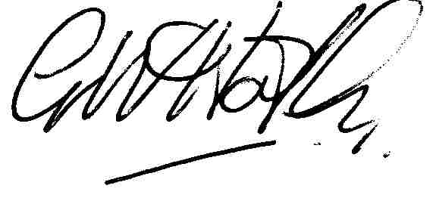
Geoff Hartley
Hon Secretary
York City and District Football Association

